Name:________________________________ I can compare and contrast how the author presents themes, topics, and

**ERQ** patterns of events in myths.

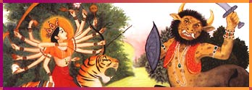 **The Buffalo Demon**

Mahisha, the fierce buffalo demon, was on a terrible mission: to conquer the world and rout the gods. He gored and slashed his way through battle after battle. The gods retired; the monster ruled — until a stupendous sound shook the earth.

Durga spoke!

The great goddess had sprung forth full-grown, created by the energy of the gods, who knew Mahisha could only be killed by a woman. Durga roared her challenge to Mahisha; the buffalo demon was enraged!

The red-robed goddess charged into battle on her magnificent lion. Her 18 arms whirled furiously overhead, each one brandishing some weapon of the gods: a thunderbolt, a trident, a bow and arrow, a rope of snakes. The buffalo demon quickly changed shapes. He became a lion, a warrior, an elephant; Durga slew each of his demon forms. Mahisha was no match for the mighty goddess. She was beautiful, invincible, fearless. Mahisha was forced to assume his monstrous buffalo shape again. He hurled mountains at the goddess. Durga dodged his attack — and then leaped up and cut off the buffalo demon's head!

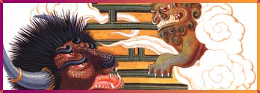 **The Oxen-Horned Giant**

Huang Di, the ancient Yellow Emperor, stood bravely at the head of his army of gods, bears, tigers, and leopards. At the other end of the battlefield loomed the oxen-horned giant Chi You, backed by his army of demons.

Huang Di came to defend his imperial throne; Chi You came to demand control of the world.

Chi You sneezed loudly and a thick, white fog covered the battlefield. No one could see a thing. Huang Di's army lashed out blindly until his quick-witted minister created a compass. Huang Di gathered the survivors and escaped.

Chi You was furious. The angry giant called in demon forces to help him. The winds blew wildly. The sky blackened and a fierce driving rain fell all over the battlefield. The Emperor's army was drowning.

Huang Di called for his most powerful weapon — his daughter Ba.

Ba strode through the flood. A terrific heat spread from her body and dried up the waters. Huang Di then fashioned a drum out of a sea monster's hide. When he crashed down his huge, powerful drumsticks, a terrible thunder shook the mountains. Chi You's army was paralyzed with fear. The Emperor's army rushed forward... to victory!

Most of India's myths, like the story of Durga, are part of Hinduism, one of the world's oldest religions. Hindu beliefs and myths are driven by two very powerful forces: creation and destruction. China has the oldest existing civilization in the world. Its earliest myths, like the Oxen-Horned Giant, date from more than 4,000 years ago. Use these two myths to answer the question below.

1. Identify a similarity between the topics presented in the myths.
2. Describe a difference between the patterns of events that occur in the myths.
3. Compare and contrast the themes presented in the myths.

