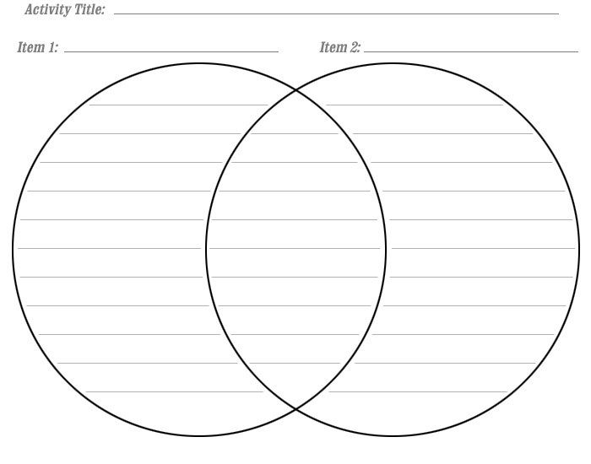
Life in the Amazon Life in My Community
Now, use clue words to write a paragraph that describes how the Amazon and your community are similar and different.

________________________________________________________________________
________________________________________________________________________
________________________________________________________________________
________________________________________________________________________
________________________________________________________________________
________________________________________________________________________

