When?

What?

Who?

How?

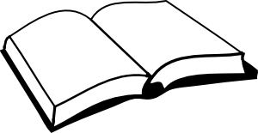

Using the passage, what question could you ask to learn more about the story?

Where?

Why?