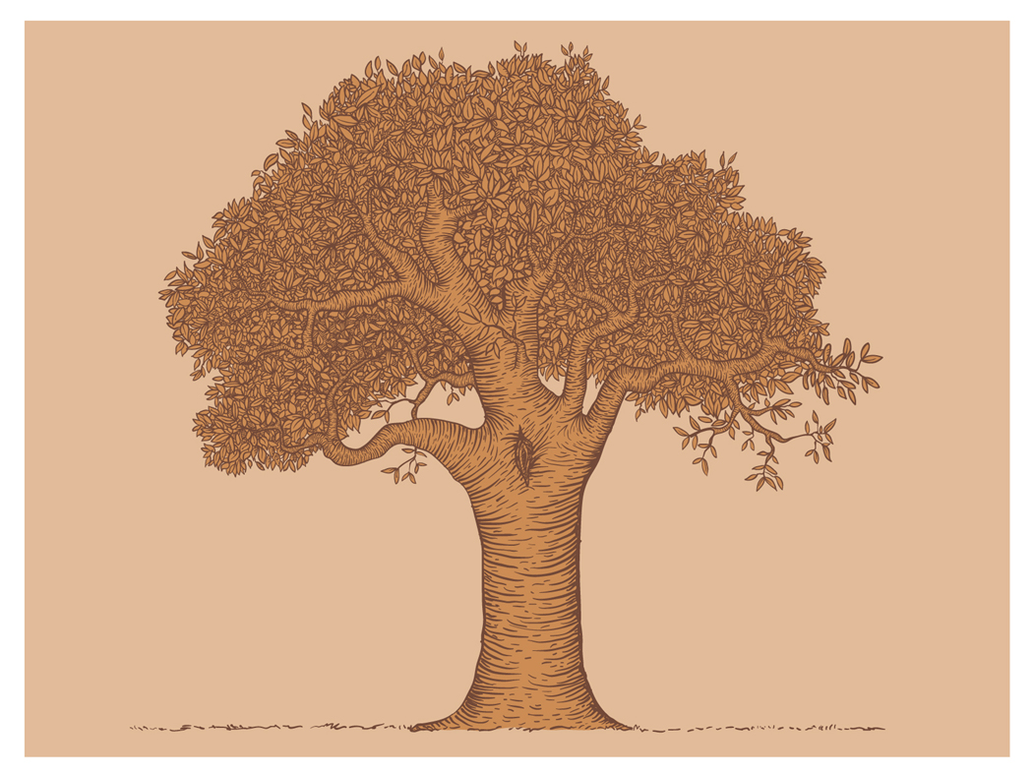

Detail

Detail

Detail

Theme:

Detail: