1st President
George Washington

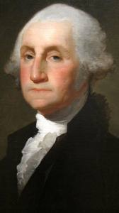

Term: 1789 – 1797

2nd President
John Adams

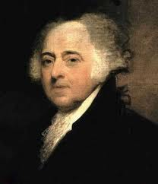

Term: 1797 – 1801

3rd President
Thomas Jefferson

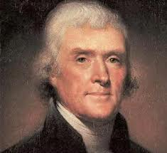

Term: 1801 – 1809

4th President
James Madison

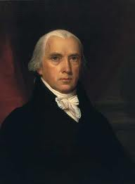

Term: 1809 – 1817

5th President
James Monroe

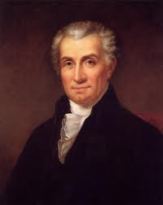

Term: 1817 – 1825

6th President
John Quincy Adams

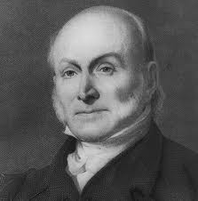

Term: 1825 – 1829

7th President
Andrew Jackson

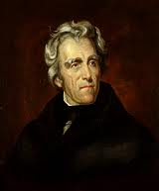

Term: 1829 – 1837

8th President
Martin Van Buren

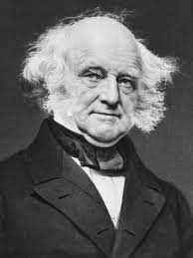

Term: 1837 – 1841

8th President
William Henry Harrison

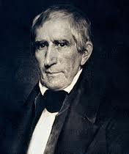

Term: 1841

9th President
John Tyler

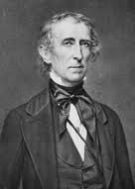

Term: 1841 – 1845

10th President
James K. Polk

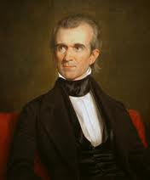

Term: 1845 – 1849

11th President
Zachary Taylor

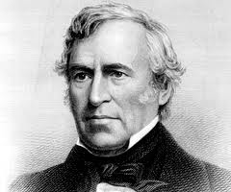

Term: 1849 – 1850

12th President
Millard Fillmore

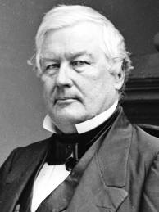

Term: 1850 – 1853

13th President
Franklin Pierce

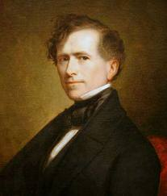

Term: 1853 – 1857

14th President
James Buchanan

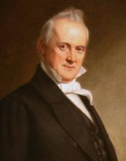

Term: 1857 – 1861

15th President
Abraham Lincoln

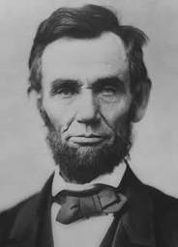

Term: 1861 – 1865

16th President
Andrew Johnson

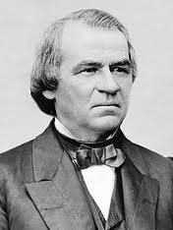

Term: 1865 – 1869

17th President
Ulysses S. Grant

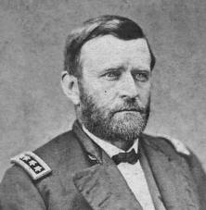

Term: 1869 – 1877

18th President
Rutherford B. Hayes

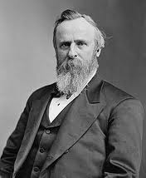

Term: 1877 – 1881

19th President
James A. Garfield

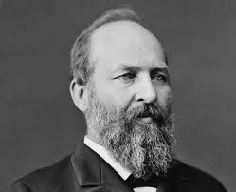

Term: 1881

20th President
Chester Arthur

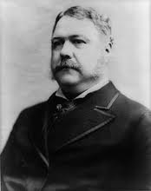

Term: 1881 – 1885

21st President
Grover Cleveland

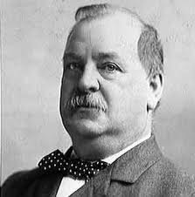

Term: 1885 – 1889

22nd President
Benjamin Harrison

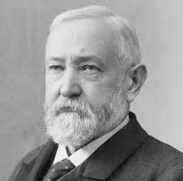

Term: 1889 – 1893

23rd President
Grover Cleveland

Term: 1893 – 1897

24th President
William McKinley

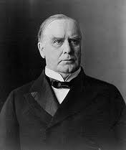

Term: 1897 – 1901

25th President
Theodore Roosevelt

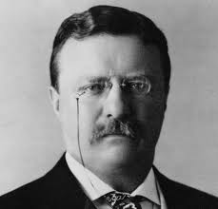

Term: 1901 – 1909

26th President
William Howard Taft

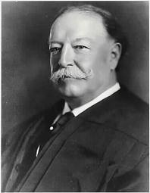

Term: 1909 – 1913

27th President
Woodrow Wilson

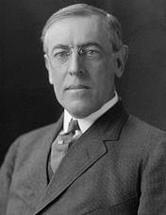

Term: 1913 – 1921

28th President
Warren G. Harding

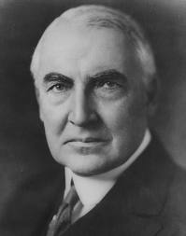

Term: 1921 – 1923

29th President
Calvin Coolidge

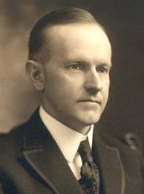

Term: 1923 – 1929

30th President
Herbert Hoover

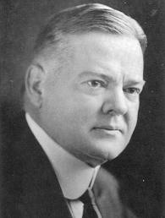

Term: 1929 – 1933

31st President
Franklin D. Roosevelt

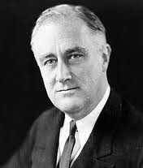

Term: 1933 – 1945

32nd President
Harry S. Truman

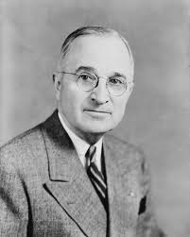

Term: 1945 – 1953

33rd President
Dwight D. Eisenhower

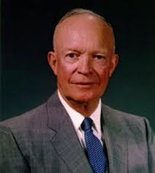

Term: 1953 – 1961

34th President
John F. Kennedy

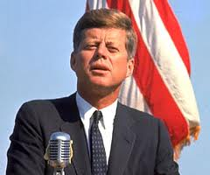

Term: 1961 – 1963

35th President
Lyndon B. Johnson

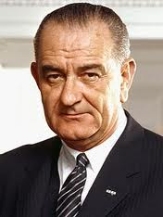

Term: 1963 – 1969

36th President
Richard Nixon

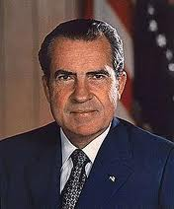

Term: 1969 – 1974

37th President
Gerald Ford

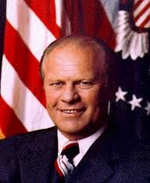

Term: 1974 – 1977

38th President
Jimmy Carter

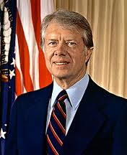

Term: 1977 – 1981

39th President
Ronald Reagan

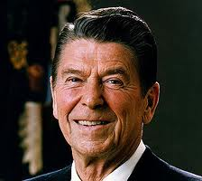

Term: 1981 – 1989

40th President
George Bush

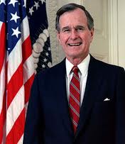

Term: 1989 – 1993

41st President
Bill Clinton

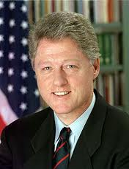

Term: 1993 – 2001

42nd President
George W. Bush

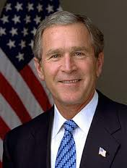

Term: 2001 – 2009

43rd President
Barack Obama

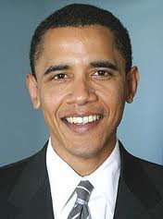

Term: 2009 - Present

